***FINAL REPORT :-***

**Introduction:-** •As we all know about COVID 19 because of that government locked down the India in 4 phases and now country is now unlocking stage but till now there is no vaccine exist some trails of vaccine is going on so  challenge is that unlocking the country with special tactics to prevent from COVID 19.

•It is clear that about buses and trains the number of buses and trains halfed now because of social distancing  for the public but number of travelers, to avail the traveling facilities for every travelers with avoiding the occupancy of public transport.

•The solution is a App which gives prebooking of seats in buses  and trains by giving the all safety guidelines,

•We give first priority to daily travelers (Pass holders) App gives them message which when their trip is , After moved toward the random travelers they have to download app and book their seat before a day and for long distance traveling buses travelers have to book their seats atleast before 15-20 days.

•There are some government apps to track the location of buses and trains it is helpful of use as a developers to  collect data to filter the all benefits for public .

•Because of the numbers of trips doubled  due to less vehicle we have to get help of a person who is master/best at operation research for benefit for both travelers and the transportation sector.

**LITERATURE SURVEY :**

**Existing problem** :- As we all know about COVID 19 because of that government locked down the India in 4 phases and now country is now unlocking stage but till now there is no vaccine exist some trails of vaccine is going on so  challenge is that unlocking the country with special tactics to prevent from COVID 19.

It is clear that about buses and trains the number of buses and trains halfed now because of social distancing  for the public but number of travelers, to avail the traveling facilities for every travelers with avoiding the occupancy of public transport.

**Proposed solution**:-The solution is a App which gives prebooking of seats in buses  and trains by giving the all safety guidelines.

We give first priority to daily travelers (Pass holders) App gives them message which when their trip is , After moved toward the random travelers they have to download app and book their seat before a day and for long distance traveling buses travelers have to book their seats atleast before 15-20 days.

There are some government apps to track the location of buses and trains it is helpful of use as a developers to  collect data to filter the all benefits for public .Because of the numbers of trips doubled  due to less vehicle we have to get help of a person who is master/best at operation research for benefit for both travelers and the transportation sector.

**THEORITICAL ANALYSIS :-**

**Block diagram**

**Hardware / Software designing**

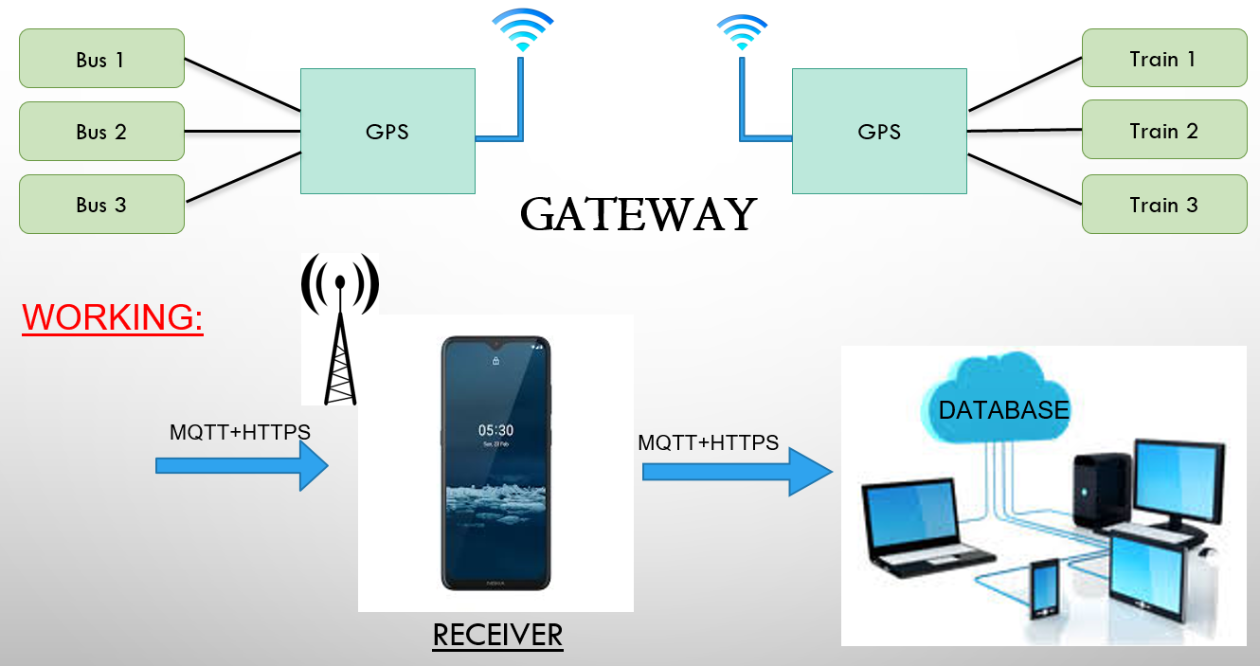

**EXPERIMENTAL INVESTIGATIONS :-**

•GPS :- For tracking current location.

•MQTT protocols :- It’s a lightweight protocol. So its easy to implement in software and fast data transmission.

•Database :- To save data on clouds.

**RESULT:-**

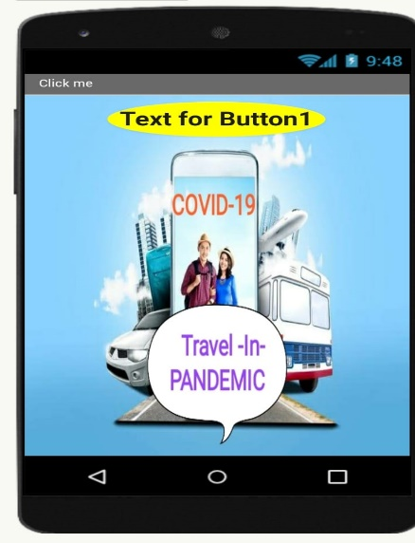

**Advantages & Disadvantages:-**

1) Main advantage is prevention from covid-19.

2) Pre booking facility is available.

3) Trip with safety.

4) Some time may be you face internet problems.

**FUTURE SCOPE:-**

•These model will be best in this current pandemic situation.

•It is very cheap and easy to access.

•One can easily protected by following the steps of the app.

•In the upcoming future our app will be of most use for protection from the infected or high risk person.